Label for each column of the csv file.

<https://github.com/streetdrone-home/Autoware/blob/master/ros/src/msgs/autoware_msgs/msg/DetectedObject.msg>

Extract images of the bag file topic one

<http://wiki.ros.org/rosbag/Tutorials/Exporting%20image%20and%20video%20data#Tutorial_setup>

Convert topic two of the bag file into csv file.

Convert the csv file to multiple txt files ⇒ one txt file for each row.

ROSBAG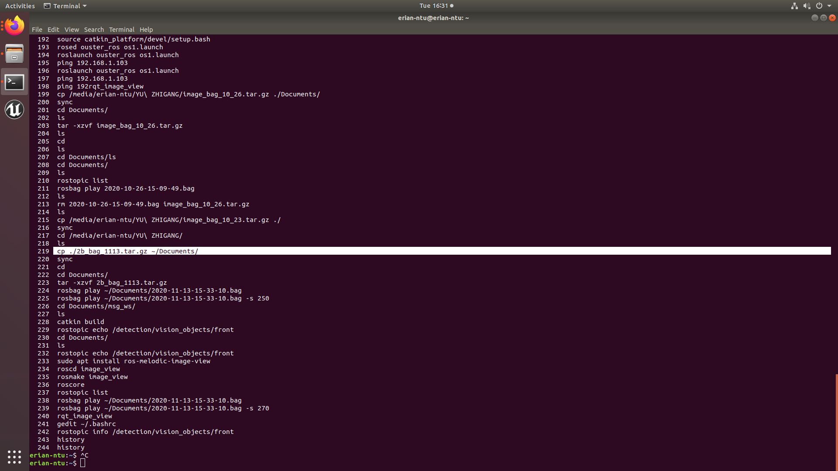

Copy the compressed file to a certain location:

cp ./2b_bag_1113.tar.gz ~/Documents/

sync

cd Documents/

tar -xzvf 2b_bag_1113.tar.gz ⇒ decompress

run roscore first.

rosbag play ~/Documents/2020-11-13-15-33-10.bag

Rosbag play ~/DOcuments/2020-11-13-15-33-10.bag -s 250

-s : starts from where

rostopic list

cd Documents/msg_ws/

ls

catkin build ⇒ build the msg type for the rostopic

Extract image from the bag file

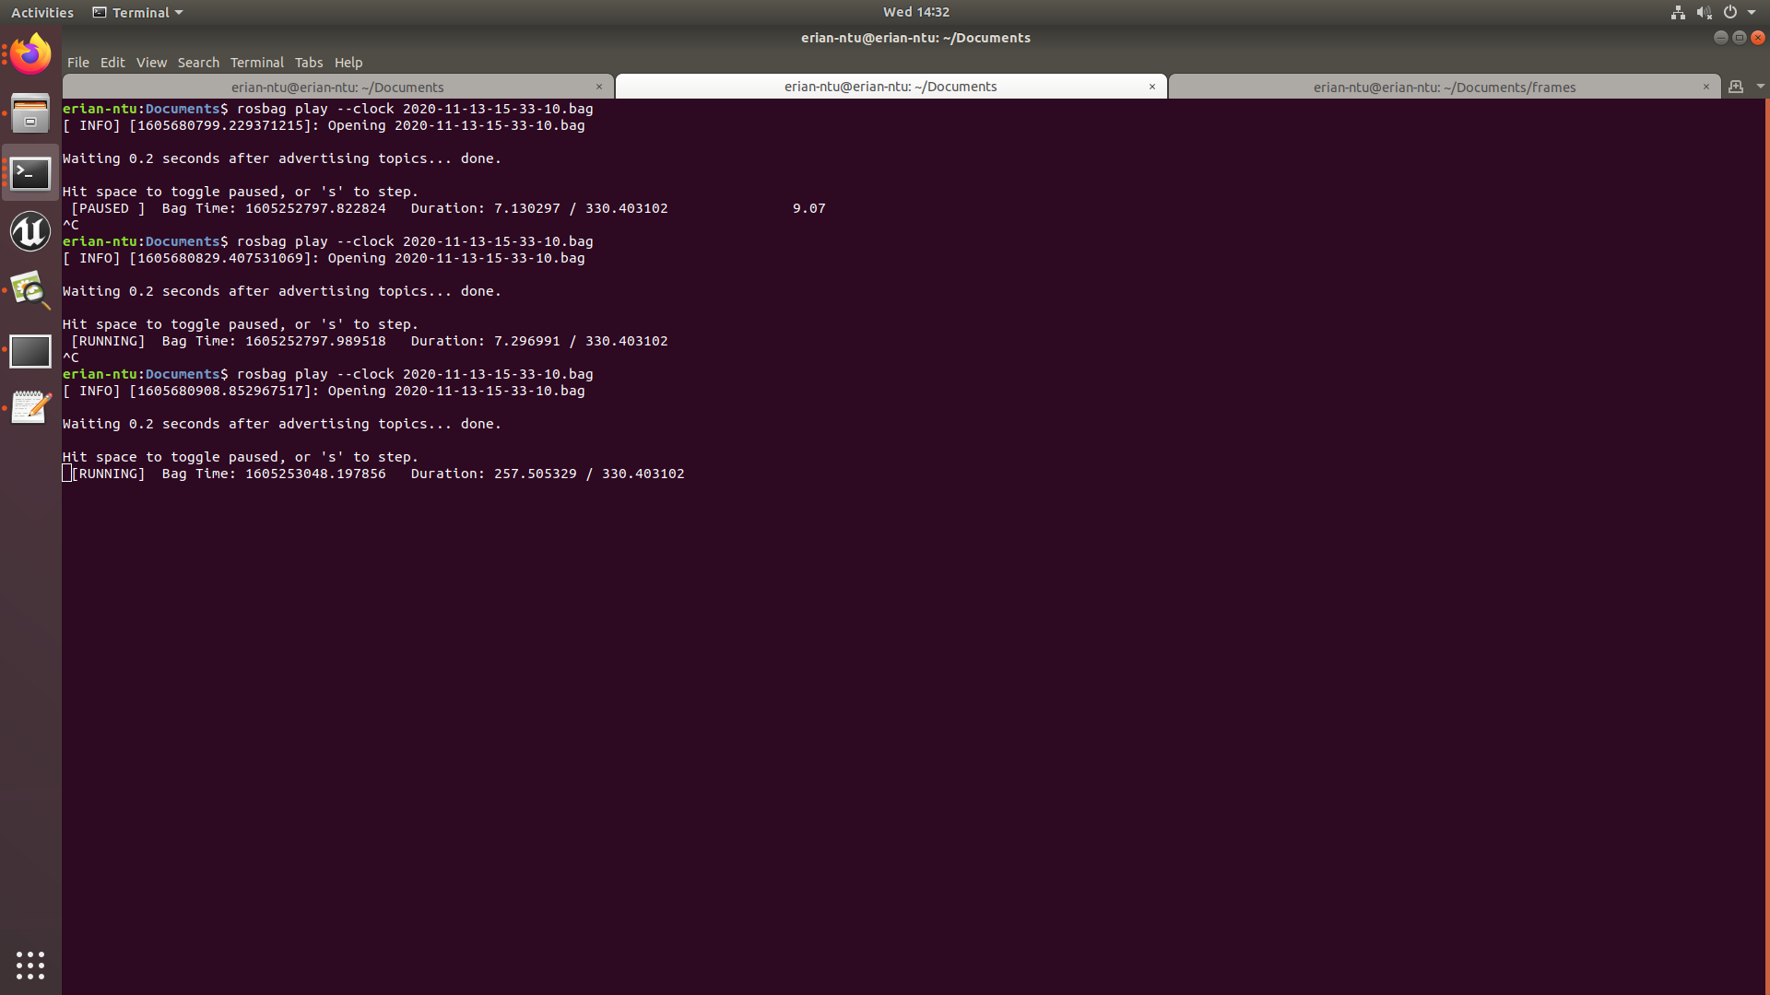

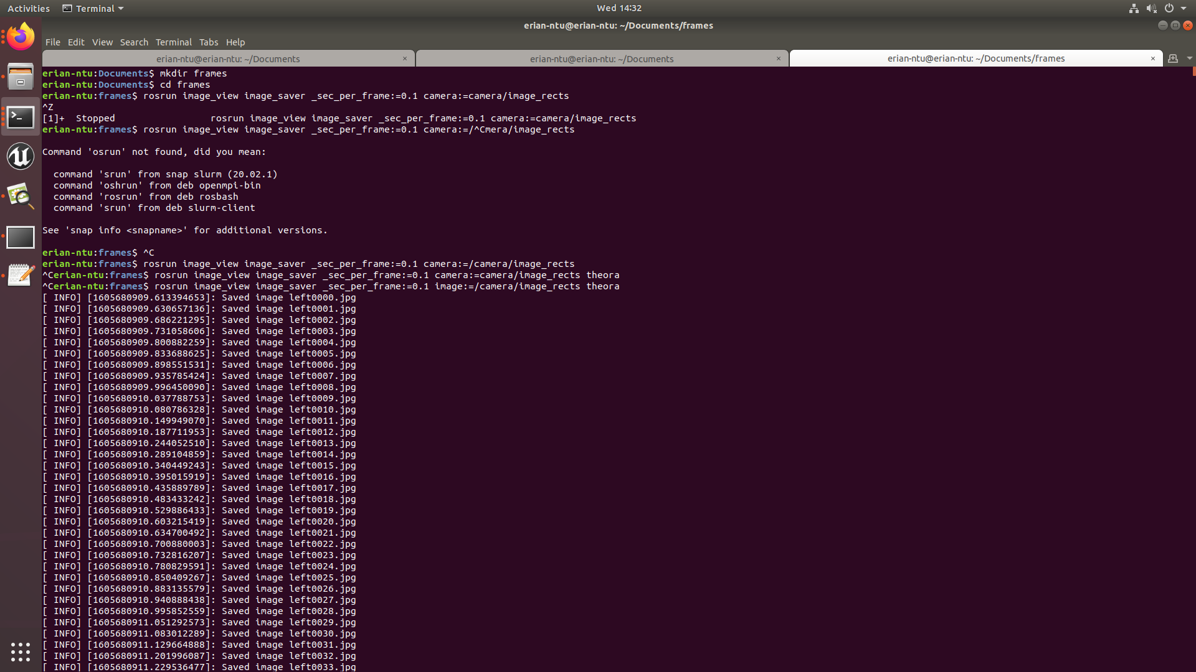

Command :

sudo apt install ros-melodic-image-view

roscd image_view

rosmake image_view

Sudo apt-get install mjpegtools

roscore

rosbag info (path of the rosbag)

rosbag play (path of the rosbag)

rosrun image_view image_saver _sec_per_frame:=0.1 image:=/camera/image_rects theora

⇒ 10 frames per second.